David Churbuck
854 Main Street
Cotuit, MA 02635
Mark Ells, Town Manager
Town of Barnstable
367 Main Street
Hyannis, MA 02601 August 30, 2023

Dear Mr. Ells,
I write in support of the Cotuit Oyster Company (COC) in the face of objections made earlier this month by a group of Oyster Harbors residents upset by the presence of floating aquaculture equipment on the COC’s aquaculture grants in Cotuit Bay and the Narrows.
This issue is neither a new nor a unique one for the town. In 2007 a different group of Osterville residents known as The Friends of West Bay persuaded the former town manager to deny the application of two commercial oyster companies to use similar “rack and bag” systems on their grants. I believed then and continue to believe today that Mr. Klimm made the wrong decision.
The Cotuit Oyster Company is one of the oldest continuously operated oyster companies in the country. It is a beloved institution in the village that made the name “Cotuit” world famous. The commercial harvest of oysters in Cotuit extends back to 1850. Three of the Oyster Harbors complaints were filed by property owners who only purchased their properties between 2020-2022.
The crux of their complaints are three issues: 1) the safety and the alleged health threats the floating bags pose to swimmers and boaters; 2) the commercial misuse of a public resource and; 3) the “public trust doctrine” that establishes the waterfront rights of private property owners and the public use of the waterways offshore of those properties.
Navigational impacts
The portion of the COC’s rack and bag equipment in the Narrows is tucked between a phalanx of private piers that encroach into the aptly named Narrows from the Oyster Harbors shoreline between Cotuit and North Bays.
In no way does the COC’s equipment in the Narrows or Tim’s Cove pose a navigational challenge to watercraft transiting the Narrows – either within or outside of the marked channel. As a rower who uses those waterways daily, I am grateful to the COC’s for placing its equipment between and inshore of the ends of the piers located at 220, 200, 180, 166 North Bay Road.
The map below (fig.1) is derived from an aerial photo found on the the Town of Barnstable’s GIS property map. It shows the location of the marked navigational channel (green hash marks), the adjacent and unofficial lane used by small boats that runs parallel to the south of that channel (yellow hashmarks), and location of the COC’s equipment (outlined in red) placed between the aforementioned piers where no watercraft can safely navigate due to the decision of the town’s conservation commission and waterways committee to grant pier permits to those Osterville property owners. Those piers, (which the residents of Cotuit were able to ban from its side of Cotuit Bay in 2007 despite the strenuous objections of Osterville’s town councilor), are true private taking of the public waters. In no way do the Cotuit Oyster Company’s equipment impede access to the privately owned piers in the Narrows.
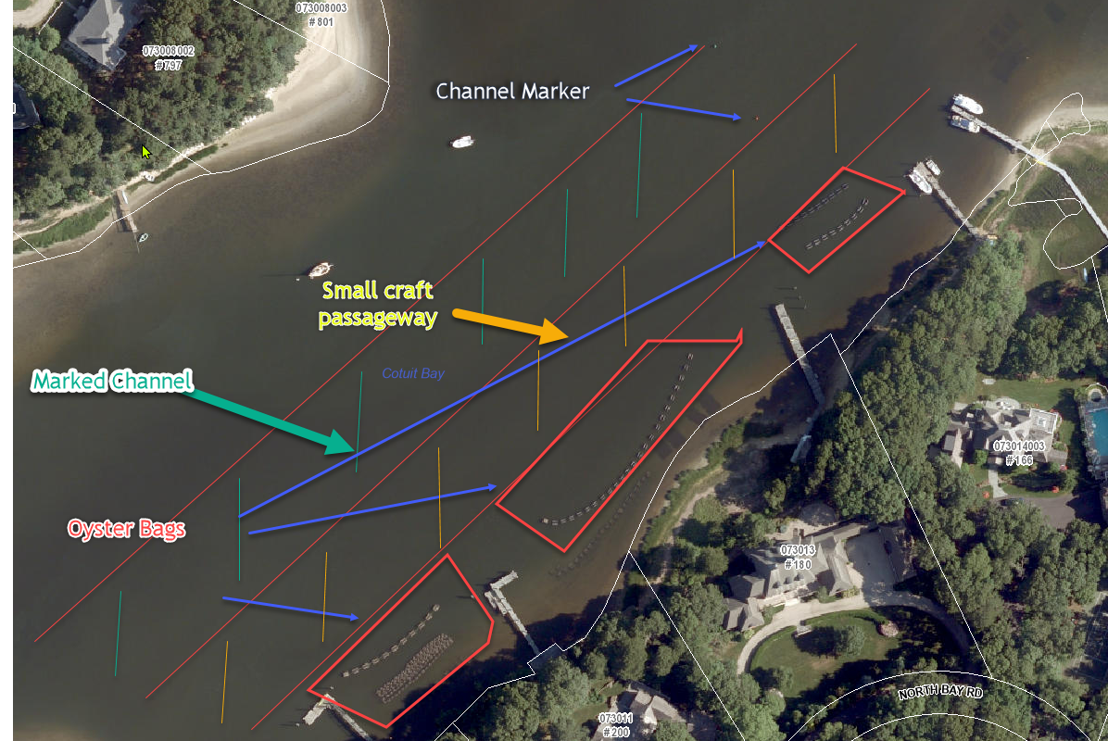
Fig. 1 The location of the Cotuit Oyster Company’s equipment inside of the Narrows

Why are the bags where they are today, and not elsewhere? Raising oysters from seed stock to a size sufficient for transfer to the COC’s grants off the western shore of Grand Island requires constant attention and care. Relocating any of the bags in Tim’s Cove or the Narrows to another portion of the Cotuit Oyster Company’s permitted aquaculture grants is unfeasible and would present a hardship to Chris Gargiulo and his employees, who require proximity to their oyster nursery operations as rack-and-bag cultivation demand constant sorting, transferring, and cleaning of the equipment.
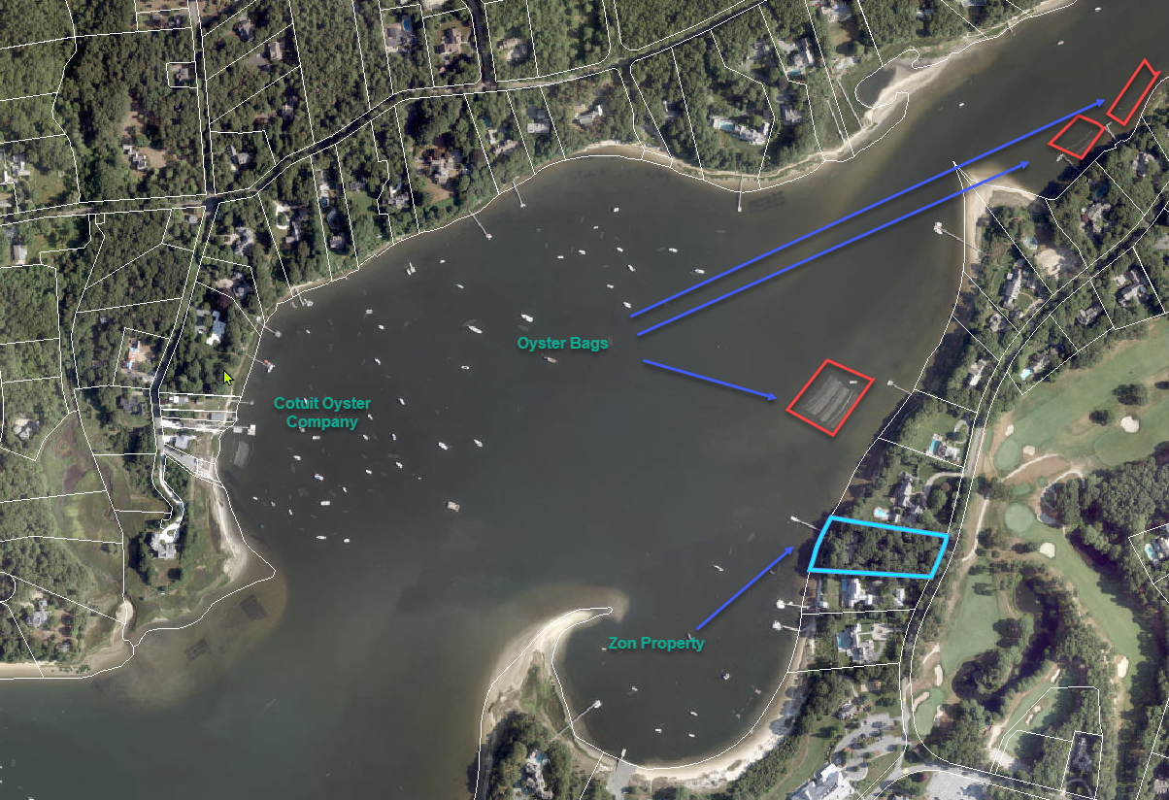
Fig 2: The Tim’s Cove location of the oyster bags
Safety concerns
The complaints claim the bags pose a safety risk, echoing the same complaints made in 2007 about Al Surprenant’s operations in West Bay. One of the “Friends of West Bay”, Missy Kalat of Osterville told the Cape Cod Times in a story published March 2, 2007:
“It looked like a football field of floating bags,” said Kalat, who lives year-round in her home. “What scared me the most was seeing the kids around it. Sailors, swimmers and kayakers. I was so concerned they would get hurt.”
Aside from opening her statement with a comment about the visual appearance of the bags, Ms. Kalat worried about a threat that simply doesn’t exist and has never occurred. I cannot find one instance where an aquaculture grant caused an accident or injury to a swimmer, sailor, or kayaker. Nor am I aware of any incident where floating oyster bags caused injury, damage, or inconvenience to any member of the public or their vessel.
Health risks
Oysters are the only thing (aside from a few I/A septic systems) presently working to reduce nitrogen levels in the Three Bays. An oyster filters 50 gallons of water a day. The COC has up to six million oysters in the bay at various stages of maturity. That is 300 million gallons of water a day being filtered by a natural process that requires no electricity, bond issues, or massive infrastructure projects. According to the National Oceanic and Atmospheric Administration’s Fisheries Division, one acre of oysters provides $6,500 in denitrification services, and shoreline stabilization benefits valued at $2,125 annually.
These complaints utterly defame the quality of the Cotuit Oyster Company’s oysters by implying they are raised in “fecal infested” waters contaminated by “repeated high fecal counts” and that the COC is breaking the law by moving clams from areas subject to seasonal closures by the town’s shellfish warden to “clean” locations before being sold. Such reckless claims, expose the complainants’ ignorance of the town’s long-standing practice of seasonal closures for many recreational shellfishing areas such as Cupid’s Cove on Sampson’s Island and Cordwood Landing. Many portions of the bays are closed during the summer months due to elevated levels of fecal coliform attributed in large part to bird feces. Many quahog relay areas —including those at Cordwood Landing and Handys Point across from Grand Island — are closed during the summer months for that reason. Those clams are eventually moved to non-compromised locations for recreational and commerce harvest where they are given enough time to flush themselves before being tested for harmful bacteria. The same holds true for the immature oysters grown in the COC’s seed bags. Once the seed oysters outgrow the bags, they are transferred to the Oyster Company’s grants on the west side of Cotuit Bay and placed in cages which much be tended and cleaned regularly before the oysters reach a saleable size.
If the five property owners from Oyster Harbors are concerned about high fecal counts and the health and safety of the public, then I look forward to reading their future letters to the Board of Health warning people to stay out of the water, especially the swimmers they must feel are endangered by swimming in the same waters where these oysters are grown.
“Industrial scale”
It is risible to describe any aspect of the Cotuit Oyster Company as “an industrial-scale” operation. It is a small business which employs five to ten people.
Impacts on dredged channels
As for the complainant’s’ speculation that above water equipment “may also undermine the massive investment of public funds in the dredging of the Cotuit Narrows.” I am unaware of any recent dredging in that area and to the best of my knowledge much of the recent dredging in the Three Bays was confined to the entrance of Cotuit Bay between Sampson’s Island and Riley Beach. Past dredging projects have been funded by a combination of private and public funds. My research shows the town spent the “massive” sum of $22,000 in 1968 to dredge the Narrows between Cotuit and Osterville.
Justification for above-water rack and bag propagation
A 2004 study by the University of Rhode Island’s Department of Fisheries and Aquaculture reported in a paper published in the Journal of Shellfish Research:
“These findings indicate that shellfish aquaculture gear provides habitat for many native species of recreationally and commercially important fish and invertebrates in their early life history stages throughout the year. Therefore, we conclude that shellfish aquaculture gear has habitat value at least equal to and possibly superior to submerged aquatic vegetation.”
Rack and bag aquaculture equipment is not used out of greed or convenience, but a matter of business survival. Oyster farms once bought seed oysters acquired from elsewhere. For years, Barnstable oysters began life in places like Connecticut and Buzzards Bay and were translated as seed into local waters. Unfortunately, that practice of planting seed oysters sourced off-Cape nadvertently introduced protozoan diseases into the local stock which devastated the industry and nearly caused it to collapse.
Dick Nelson, the previous owner of the Cotuit Oyster Company had to, according to a 2006 story in the Barnstable Patriot, “…confront an unfortunate event when the company bought seed that turned out to be contaminated, setting the business back for several years.”
Fortunately for the Cape’s aquaculture industry, a disease resistant strain of oysters was found which some experts say was the catalyst kicked off the oyster craze that has put a such premium on Cape Cod’s oysters from Cotuit to Wellfleet. Advances in the cultivation of brood stock through upwellers and the use of the same mesh bags the complaints object to have helped dramatically reduce protozoan diseases such as Demo, MSX, and SSO, while protecting vulnerable seed oysters from predators that prey on them when they are planted on the bottom of the bay.
The Public Trust Doctrine and waterfront property rights
Massachusetts is the only state in the country to grant waterfront property owners rights to the “wet sand” below the mean high-water mark. The COC has been nothing but respectful and accommodating of those rights, and despite allegations made in the complaints, the COC has tried to minimize the impact of its gear by submerging it underwater in the winter and placing far less visible equipment on its grants than it is entitled to place there.
It's all about the view
Why are aquaculture operations along the entire east coast fighting to stay in business in the face of growing opposition and expensive lawsuits brought against them by wealthy waterfront property owners?
The complaints, for all their pious handwringing about the public good, are about protecting property values and views.
“Up and down the East Coast, as fishing has become less profitable, fish piers have been replaced with condos and fishing boats have been pushed out by yachts, according to Bob Rheault, the executive director of the East Coast Shellfish Growers Association.
“We live in a rural area, so there’s a ton of space to do things, but our access is limited when it comes to the waterfront,” said Black. While she has found that aquaculture farmers in the area don’t lack places to live or clean their equipment, she has noticed in recent years a growing tension between farmers and people moving in. In her experience, newcomers don’t often understand what an oyster farm is and don’t want one in their backyard.”
In 2019 the North Carolina Division of Marine Fisheries issued a “Study On How to Reduce User Conflict Related to Shellfish Cultivation Leases” which sums up the true motivation behind the surge in property owners complaints against aquaculture in their front yard:
“Many user conflict cases brought by riparian owners adjacent to shellfish lease locations seem to be driven by a concern for viewshed. Viewshed is not a public trust right traditionally acknowledged under North Carolina common law.”
Please dismiss these complaints and clean up the bays
I implore the town to dismiss these complaints and consider the source. I assume the five parties on Oyster Harbors have the funds to sue the town and most likely will if the town doesn’t kowtow to their demands. I say bring it on. These complaints are only the skirmish in what promises to be an expensive court battle and an attempt to deny the Cotuit Oyster Company a renewal of its permits when they come due next year. Please shut down this blatant attack on the character and health of the waters of Barnstable and send a message to these latest so-called “Friends of the Bay” that this is a town that was built on the water by people who made their living on the water, and not a one ruled by those who sell the land around it and build the homes that overlook it. Revise the commercial shellfishing regulations to encourage the cultivation of shellfish. They are the proverbial canary in the coal mine and action is needed now – not twenty years from now – to revise the CWMP and prioritize “time to travel” septic systems for immediate connection to a sewer, I/A system, or composting toilets.
Sincerely Yours,
David Churbuck
cc:
Town Councilor Gordon Starr, Councilor Eric R. Steinhilber, Councilor Betty Ludtke, Councilor Nikolas Atsalis, Councilor Paul Cusack, Councilor Paul C. Neary, Councilor Jessica Rapp Grassetti, Councilor Jeffrey Mendes, Councilor Tracy Shaughnessy, Councilor Mathew P. Levesque, Councilor Kristine Clark, Councilor Paula K. Schnepp, Councilor Jennifer L. Cullum, Derek Lawson, Director, Marine and Environmental Affairs, Amy Croteau, Shellfish Constable, Stuart Rapp, Chair-Barnstable Shellfish Committee, Brian W. Taylor, Harbormaster, Chris Garigulo, Cotuit Oyster Company, Ed Gargiulo, Carol Zais, Cotuit Santuit Civic Association

Journal of Shellfish Research, Vol 23. No 3 867-875 2004, Dealteris, Kilpatrick and Rheault
https://civileats.com/2023/04/03/young-oyster-farmers-struggle-as-working-waterfronts-disappear/
https://www.deq.nc.gov/marine-fisheries/11-2019-mfc-meeting-archive/user-conflict-related-shellfish-cultivation-leases/open

